Order Of Service

Singing: Psalm 148—CW page 121

Reading: Psalm 103

Opening Hymn: TLH 42

Reading: Acts 20:13-16

Request Hymn: CW Supplement 748

Reading: Matthew 8:5-13

Sermon Hymn: TLH 39

Sermon Text: Mark 7:31-37

Ears And Tongue

Prayer

The Apostles’ Creed, TLH page 12

Holy Communion

The Lord's Prayer

The Blessing

Closing Hymn: TLH 49

* * * * * * * * * * *

Bible Study: Lambs: Termite
Sheep: Proverbs 18:21-24


Duluth Storm

Water
Of
Life

30 June 2019

W A T E R O F L I F E

Independent Christian Church—Conservative Lutheran Doctrine

Worship Service: 9:30 a.m. Bible Study: 10:45 a.m.

Larry Cooper, Pastor E-Mail address:
111 N. Ridge Road lcooper@wateroflife.cc
Coon Valley, WI 54623 Web Site:
www.wateroflife.cc

* * * * * * * * * * * * * * * * * * * * * * * * * * *

Sermon Text: Mark 7:31-37

Ears And Tongue

* * * * * * * * * * * * * * * * * * * * * * * * * * *

Mark 7:31 And again, departing from the coasts of Tyre and Sidon, he came unto the sea of Galilee, through the midst of the coasts of Decapolis.
:32 And they bring unto him one that was deaf, and had an impediment in his speech; and they beseech him to put his hand upon him.
:33 And he took him aside from the multitude, and put his fingers into his ears, and he spit, and touched his tongue;
:34 And looking up to heaven, he sighed, and saith unto him, Ephphatha, that is, Be opened.
:35 And straightway his ears were opened, and the string of his tongue was loosed, and he spake plain.
:36 And he charged them that they should tell no man: but the more he charged them, so much the more a great deal they published it;
:37 And were beyond measure astonished, saying, He hath done all things well: he maketh both the deaf to hear, and the dumb to speak.

* * * * * * * * * *

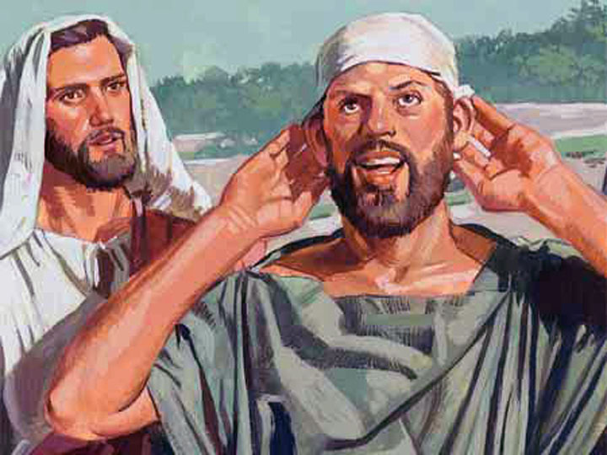

Hearing Ears & Speaking Tongue

